COS 226 Algorithms and Data Structures Fall 2008

Final Solutions
1. Depth-ﬁrst search.
(a) ABCFEGDH
(b) EDGFHCBA

(c) false, true, true
2. Minimum spanning tree.
(a) 1 2 3 4 5 11 12 13 17
(b) 4 3 2 1 5 13 12 17 11

3. Convex hull.
(a) BCDGHFJIE
(b) 1. A->B->C
    - A->B->C->D
    - A->B->G
    - A->B->H
    - A->B->H->F
    - A->B->H->F->J
    - A->B->H->F->J->I
    - A->B->H->E
    - 4. TST.
    - (a) aaa aab ab ba bb bba bbbb

(b)
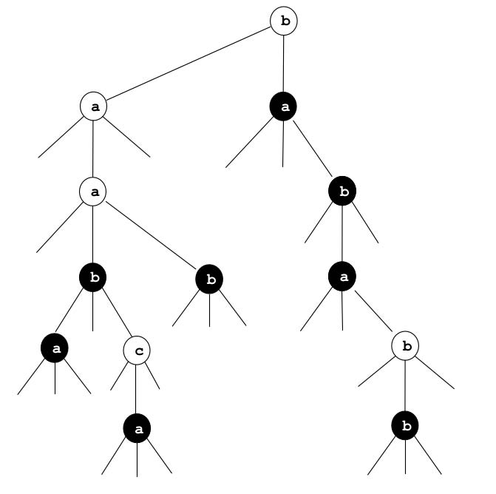
5. 2D tree.
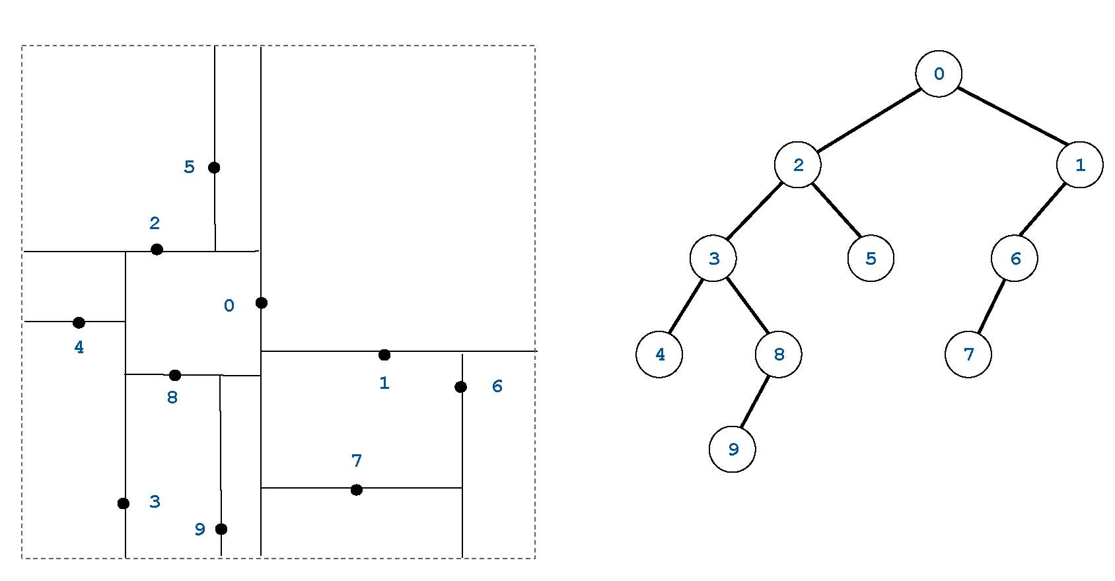
6. Radix sorting.
Put an X in each box if the string sorting algorithm (the standard version considered in class) has the corresponding property.
 | mergesort | LSD radix sort | MSD radix sort | 3-way radix quicksort
stable | X | X | X
in-place |  |  |  | X
sublinear time (in best case) | X |  | X | X
ﬁxed-length strings only |  | X

Note that in the best case, mergesort takes N log N string compares, but a string compare can takes constant time (if the two strings diﬀer after a constant number of characters). Thus, the overall running time can be sublinear in the input size (total number of characters in the N strings).
7. Data compression.
ababbababbabbabb
8. Regular expressions.
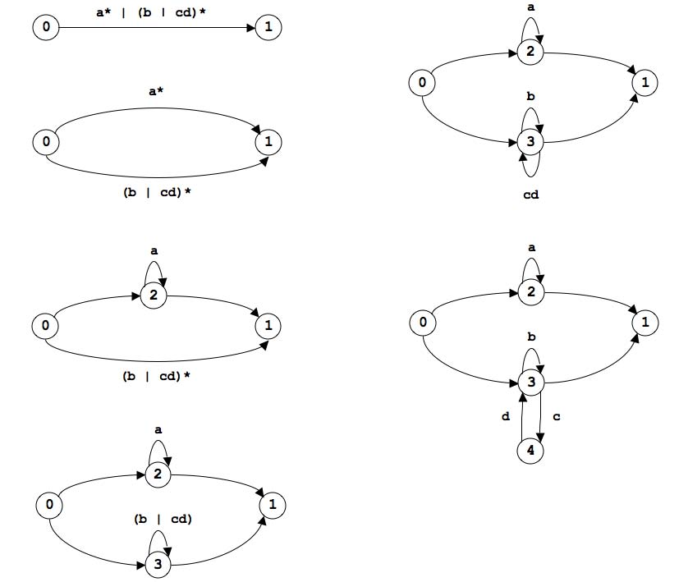
9. 1D nearest neighbor.
- constructor: create an empty red-black tree.
- insert(x): insert x into the red-black tree.
- query(y): if the data structure is empty return null; otherwise compute the ﬂoor and ceiling of y and return the (non-null) value closest to x.

10. Preﬁx-free codes.
(a) Insert all of the codewords into a binary trie, marking the terminating nodes. The set of string is not preﬁx-free if when inserting a codeword (i) you pass through a marked node (an existing codeword is a preﬁx of the codeword you are inserting) or (ii) the node you mark is not a leaf node (the codeword you’re inserting is a preﬁx of an existing codeword).
(b) W (we go down one level in the tree for each bit we examine).
(c) W (at most one trie node for each bit in the input).

Alternate solution 1: use a TST instead of a binary trie. Since the radix size is 2, the running
time will still be linear: you at most double the length of a search path for a codeword. Alternate solution 2: sort all of the codewords (MSD radix sort or 3-way radix quicksort) and check adjacent codewords to see if one is a preﬁx of the other.
11. Shortest directed cycle.
(a) The critical observation is that the shortest directed cycle is a shortest path (number of edges) from s to v, plus a single edge v→s.
For each vertex s:
- Use BFS to compute shortest path from s to each other vertex.
- For each edge v->s entering s, consider cycle formed by

shortest path from s to v (if the path exists) plus the edge v->s. Return shortest overall cycle.
(b) The running time is O(EV ). The single-source shortest path computation from s takes O(E +V ) time per using BFS. Finding all edges entering s takes O(E + V ) time by scanning all edges (though a better way is to compute the reverse graph at once and access the adjacency lists). We must do this for each vertex s. Thus, the overall running time is O(EV ).
(c) The memory usage is O(E + V ). BFS uses O(V ) extra memory and we only need to run one at a time. (A less eﬃcient solution is to compute a V -by-V table containing the shortest path from v to w for every v and w. This uses O(V 2) memory.)

12. Reductions.
(a) 0,x1,x2,...,xN . This is the easy direction—we just choose b = 0.
(b) 3x1 − b, 3x2 − b, . . . , 3xN − b. Observe that (3xi − b) + (3xj − b) + (3xk − b)=0 if and only if xi + xj + xk = b. Note that we use 3xi − b as the input instead of xi − b/3 because the input must be integral.
(c) I, II, and III.

